American International University-Bangladesh (AIUB)

**Thesis**

***Skin cancer detection using ResU-netplusplus and U- net***

**Submitted By**

|  |  |
| --- | --- |
| **Name** | **Id** |
| **TANVIR TANJUM NAFIS** | **18-39156-3** |
| **MD. EASHIN JAHANGIR JOY** | **18-36185-1** |
| **D. M. TAREQ ANNAN** | **19-40999-2** |
| **TAJIN MOSTOFA** | **18-36740-1** |

Department of Computer Science

Faculty of Science and Technology

American International University Bangladesh

October, 2022

|  |
| --- |
| **Declaration** |

We declare that this project is our original work. No part of this has been submitted elsewhere partially or fully for the award of any other degree. Any material reproduced in this project has been properly acknowledge.

We declare that this project does not contain any content that discloses the secret of any organization or related parties. American International University-Bangladesh (AIUB) will not be held liable for any such activity, as for the project is presented as our original work.

|  |  |
| --- | --- |
| _______________________________  **Group Member 1**  **18-39156-3**  CSSE | _______________________________  **Group Member 2**  **18-36185-1**  CSE |
|  |  |
| _______________________________  **Group Member 3**  **19-40999-2**  CSE | _______________________________  **Group Member 4**  **18-36740-1**  CSE |

|  |
| --- |
| **Approval** |

The thesis titled “***Skin cancer detection using ResU-netplusplus and U- net***” has been submitted to the following respected members of the board of examiners of the department of computer science in partial fulfillment of the requirements for the degree of Bachelor of Science in Computer Science on (date of defense) and has been accepted as satisfactory.

|  |  |
| --- | --- |
| _______________________________  **DR. Hossain MD. Shakhawat**  Assistant Professor and Supervisor  Department of Computer Science  American International University-Bangladesh | _______________________________  **DR. MD. Taimur Ahad**  Rank and External  Department of Computer Science  American International University-Bangladesh |
| _______________________________  **DR. MD. Abdullah – Al – Jubair** Head (Undergraduate Program) Department of Computer Science American International University-Bangladesh | _______________________________  **Professor Dr. Tafazzal Hossain** Dean Faculty of Science and Technology American International University-Bangladesh |
| _______________________________  **Dr. Carmen Z. Lamagna**  Vice Chancellor  American International University-Bangladesh | |

|  |
| --- |
| **Acknowledgement** |

This research is our cordial effort and our supervisor’s initiative and constant motivation. But first of all, we would like to be grateful to the Almighty Allah, who gives us the effort to work on this project for the last **one** semester. Especially thanks go to our honorable supervisor DR. Hossain MD. Shakhawat faculty member, American International University-Bangladesh [AIUB] for his enormous support, inspiration, and helpful criticism. His excellent supervision and constant support make this project possible. We are very grateful to him for giving us the opportunity to work with him. We also convey our thanks to our honorable Vice Chancellor, Dr. Carmen Z. Lamagna, our Dean, Prof. Dr. Tafazzal Hossain, our Associate Dean, Mashiour Rahman, our Director, Dr. Dip Nandi, and our Head of Department, DR. MD. Abdullah – Al – Jubairfor their constant motivation and support.

Last but not least we thank our respectable parents for educating us with aspect from both arts and sciences, for their unconditional support and encouragement to pursue out interests, even when interests went out of boundary.

**TABLE OF CONTENTS**

**Thesis Summary** 5

**CHAPTER 1: INTRODUCTION** 7

**1.2 Thesis Background/Problem Analysis** 7

**1.3** **Literature Review of Existing studies** 8

**CHAPTER 2: RESEARCH METHODOLOGY** 8

**2.1 Conceptual understanding** 8

**2.3** **Data Collection** 10

**2.2** **Ethical Issue** 10

**CHAPTER 3: THESIS PLAN** 10

**3.1** **Project/Thesis Effort Estimation** 10

**3.2** **Project/Thesis Planning** 11

**3.3** **Uncertainties and Risk Analysis** 11

**3.4 Thesis Execution** 12

**CHAPTER 4: RESULTS AND ANALYSIS** 13

**4.1** **Solution Description** 13

**4.2 Impact on Environment:** 15

**CONCLUSION** 15

**REFERENCE** 16

# **Thesis Summary**

Given that skin conditions are among the most well-known human illnesses, intelligent categorization systems for skin conditions have emerged as a new area of research that is of utmost significance for dermatologists. Due to the intricacy of the skin's texture and the disease's visible proximity, it can be quite difficult to accurately identify the infection. Skin photos are filtered to remove unwanted noise and then further processed to enhance the image. We tested clinical skin disease images, training images from various lesions of eight categories, and images with no skin conditions at various anatomic places. This classifier was used to categorize skin lesions such as benign keratoses, actinic keratoses, basal cell carcinomas, melanocytic nevi, vascular lesions, and melanoma. The classification of skin lesions such as vascular lesions, melanoma, basal cell carcinoma, melanocytic nevi, actinic keratoses, benign keratoses, dermatofibromas, and squamous cell carcinomas was done using this classifier.

When classifying a picture and obtaining a diagnosis report as a confidence score with high accuracy, complex approaches like Residual Neural Network (ResNet) and U- net is used. By omitting the identical lavers, ResUNetPlusPlus speeds up the training process rather than U- net

Every additional layer of the training process effectively improves it. Analysis of this study can assist specialists in making an early diagnosis, determining the kind of illness, and starting any necessary treatments.

|  |
| --- |
| **CHAPTER 1: INTRODUCTION** |

***1.1 Skin cancer detection using ResU-netplusplus and U- net***

Cancer is the unregulated growth of tissues in a particular bodily part. It appears that skin cancer is one of the global diseases that spreads the fastest. Skin cancer is a condition in which out-of-control development of abnormal skin cells occurs. Early identification and precise diagnosis are crucial for determining viable cancer therapy.

The most common cause of skin cancer-related mortality in industrialized nations is melanoma, the deadliest kind of skin cancer. Basal cell carcinoma, squamous cell carcinoma, Merkel cell cancer, dermatofibroma, vascular lesion, and benign keratosis are the main varieties of skin cancer. Skin cancer, breast cancer, and brain tumors are just a few examples of the abnormalities that may be detected in different parts of the body. A major role is played by diagnostic imaging assessment in cases of stomach and lung cancer. In 2020, there will be 9.9 million cancer deaths and 19.2 million new cancer diagnoses, according to the GLOBOCAN survey. The most common cause of death is lung cancer, which accounts for 18.2% of all fatalities. Colorectal cancer comes in second with 9.5%, followed by liver cancer (8.4%), stomach cancer (7.8%), breast cancer (6.9%), esophageal cancer (5.5%), and pancreatic cancer (4.7%). More than 50% of cancer fatalities, along with around 20% of cancer deaths in Europe, are reported by the GLOBOCAN study to have occurred in Asia. Figure 1 also depicts the regions of the world where skin cancer is most prevalent, with North America making up nearly half of the total.

# **1.2 Thesis Background/Problem Analysis**

Skin cancer occurs more frequently than all other cancers put together. The incidence rates of both melanoma and nonmelanoma skin cancer are rising. Each year, there are million new instances of basal and squamous cell carcinomas in the USA. Malignant melanoma cases increase by 76 380 each year. are cause for concern for patients and the system of health care. Treatment for skin cancer in the US costs more than $8 billion. Skin cancer is the seventh most expensive malignancy for Medicare in terms of annual costs. Moreover, skin cancer is a concern that is little appreciated for many different demographics, particularly young women and minorities like homosexual guys and Hispanic people. What can we do if universal screening is not the best course of action? The response is yes, we can. The answer is yes, we can accomplish a lot if we move our attention from secondary prevention (detecting cancer in time for treatment) to primary prevention (preventing the cancer from developing in the first place). More than half of malignancies are thought to be curable with medicine, vaccines, or lifestyle changes. According to the data, skin cancer may often be avoided. This is why we performed this research to provide assistance those who are in need for the service. So that it can slightly help the affected person.

# **Literature Review of Existing studies**

Google Scholar was used to conduct the literature review. The terms "Skin cancer, detecting approaches, diagnosis, non-invasive" were searched for between 1990 and 2017. A list of articles that were appropriate based on the search results was displayed, and some of those articles were picked. Fig. 2 displays historical publication patterns. For scholars who intend to further investigate this topic, this review paper will be encouraging.

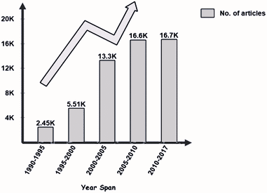

Our research will help to detect the skin cancer faster. Then the existing studies. it will save a lot of time and money those who are in need.

|  |
| --- |
| **CHAPTER 2: RESEARCH METHODOLOGY** |

# **2.1 Conceptual understanding**

In order to process biological images, UNet, which developed from the traditional convolutional neural network, was first created in 2015. As a well-known convolutional neural network, it has chosen to focus on the photo category, where the input is an image and the output is a single label. However, in biomedical situations, we must not only determine whether or not there is a problem but also to what extent. Determine the precise location of the anomaly. This systematic analysis of the literature was done to identify and classify the top methods for employing neural networks to detect skin cancer (NNs). Systematic literature reviews compile and evaluate available research using predetermined evaluation criteria. Reviews like this one assist in determining what is already known in the subject area. All primary source data is compiled, then categorized and examined. A more sensible, logical, and solid response to the research’s central question is offered once systematic literature is complete. Framework for Research The systematic review’s initial step was to define the review framework. It was made up of a comprehensive plan that was carried out in the systematic literature review. The plan was divided into three layers: planning; selecting and analyzing data; and producing findings and drawing conclusions. Selection and Evaluation Procedure: The search produced 1483 research papers and conference reports using the initial search parameters. 95 papers with titles deemed pertinent to our inquiry were chosen from the identified papers. The number of those chosen papers was then reduced to 64 research papers as a result of a closer examination of the relevancy of their abstracts. The research papers that made it through the abstract-based selection process were thoroughly examined. 51 research papers were chosen for the final evaluation after a thorough examination of their quality. In the final selection, 25% of the papers were from IEEE publications, 16% came from Google Scholar, 10% from ACM DL, 29% from Springer, and 20% from Science Direct. Neural networks that use convolution CNNs are neural networks with a particular topology that have been shown to be extremely effective in fields like image recognition and sort [17]. CNNs have been demonstrated to perceive faces, equipment, and visitor symptoms above human beings, resulting in decisions being made in robotics and self-driving cars. CNNs are trained because their learning process is always being scrutinized. The use of data that has been categorized with the appropriate instructions. Briefly said, CNNs investigate the relationship between the layers that are buried, from which the features are extracted, as well as components, such as: objects and elegant labels Taking a break Layers that are closely related and can be used to create authentic class assignments are processed.

**2.2 Research Questions**

Research questions must be developed in order to carry out an efficient systematic literature evaluation on a subject. The following were the research questions developed for the current systematic study:

1. What are the main deep learning methods for skin cancer detection?
2. What are the primary characteristics of skin cancer datasets that are currently available?

Top of Form

# **Data Collection**

We collected our data from [ISIC Challenge (isic-archive.com)](https://challenge.isic-archive.com/data/)

There are 900 dermoscopic lesion images in JPEG format, with EXIF data stripped.

# **Ethical Issue**

This is necessary because the dataset only offers patient labels at the image-level. This is another phase that the data loading module implements. The simulation would determine if any malignant The patient in the batch who has the lesion photos creates a tensor with the value 1. If any, and create a tensor with a value of 0 if none exist. Using this tensor Become the patient level label that is applied to the model during training and testing. The ground truth for each patient, which is whether the patient has submitted photos of malignant skin lesions, will be compared to the forecast for each patient.

|  |
| --- |
| **CHAPTER 3: THESIS PLAN** |

# **Thesis Effort Estimation**

The aims of this research are to improve the quality of existing diagnostic systems by  
proposing 283 new feature extraction, selection and classification methods. These methods  
are aimed for early detection of pathologic melanoma. This process provides a better tool  
for screening and detecting lesions that are considered to be suspicious allowing early  
treatment and improved survival rate. The research focuses on the proposed algorithm that  
is a combination of segmentation methods for skin cancer image to detect the lesion border  
(edges), followed by feature extraction, selection and classification. The diagnostic results  
of the proposed system are compared with other algorithms as well.

# **Thesis Planning**

A systematic and well-planned search is very important for collecting useful material from the searched data of the desired domain. In this step, a thorough search was conducted to extract meaningful and relevant information from the mass of data. We created an automated search mechanism for filtering out the desired domain’s data from all sources. Research papers, case studies Websites containing information regarding skin cancer, the dangers of skin cancer, the reasons for skin cancer, and NN techniques of skin cancer detection were all carefully searched. For extraction of the desired and relevant data, we conducted our search according to the following parameters. We conducted our initial search on well-reputed search engines such as IEEE explore, ACM, Springer as well as Google Scholar to extract information relevant to NN techniques for skin cancer detection. Basic research material related to the underlying topic was filtered out in the primary search. The selected research papers and conference proceedings were further analyzed according to evaluation criteria.

# **Uncertainties and Risk Analysis**

Accurate automated medical image recognition, including classification and segmentation, is one of the most challenging tasks in medical image analysis. Recently, deep learning methods have achieved remarkable success in medical image classification and segmentation, clearly becoming the state-of-the-art methods. However, most of these methods are unable to provide uncertainty quantification (UQ) for their output, often being overconfident, which can lead to disastrous consequences. Bayesian Deep Learning (BDL) methods can be used to quantify uncertainty of traditional deep learning methods, and thus address this issue. We apply three uncertainty quantification methods to deal with uncertainty during skin cancer image classification. They are as follows: Monte Carlo (MC) dropout, Ensemble MC (EMC) dropout and Deep Ensemble (DE). To further resolve the remaining uncertainty after applying the MC, EMC and DE methods, we describe a novel hybrid dynamic BDL model, taking into account uncertainty, based on the Three-way Decision (TWD) theory. The proposed dynamic model enables us to use various UQ methods and different deep neural networks in distinct phases. So, the elements of each phase can be adjusted according to the dataset under consideration. In this study, two UQ methods are applied in two phases to analyze two well-known skin datasets, thus preventing one from making overconfident decisions when it comes to diagnosing the disease.

|  |  |  |  |  |
| --- | --- | --- | --- | --- |
| **S/N** | **Risk Description** | **Probability** | **Impact** | **Mitigation Plan** |
| 1 | Unrealistic time estimate | 40% | Significant | Take multiple estimation |
| 2 | knowledge | 20% | Normal | Take multiple estimation |
| 3 | Resources | 25% | Significant | Take multiple estimation |
| 4 | Software Errors | 15% | Significant | Take multiple estimation |

# **3.4 Thesis Execution**

|  |  |
| --- | --- |
| **Tasks** | **Start-End Dates** |
| 1. Preliminary Thesis Plan | 2021.08.01 |
| 1. Requirements Specification | 2021.08.07 |
| 1. Analysis [Object model, User interface] | 2021.08.20 |
| 1. Source Code | 2021.09.01-2021.12.01 |
| 1. Test Plan | 2022.01.01-2022.07.01 |
| 1. Final Product | 2022.07.15- 2022.10.10 |

|  |
| --- |
| **CHAPTER 4: RESULTS AND ANALYSIS** |

# **Solution Description**

**Using u-net**

The training dataset consists of two components: the original Color picture and the image mask. In the image affected areas and their mask images are shown below.

Original mask

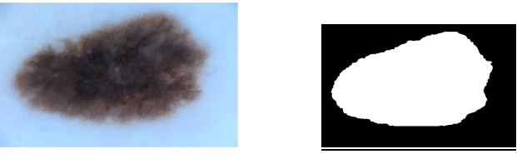

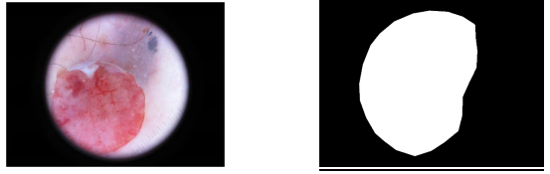

Basic UNet model was implemented and it was trained used 25 epochs, activation function “sigmoid” and optimizer “adam". Hyper Parameter Optimization Space Epoch 25 but completed in 8, Batch Size 16, Optimizer Adam, Accuracy rate:93.24%

**After training the model it can generate mask images.**

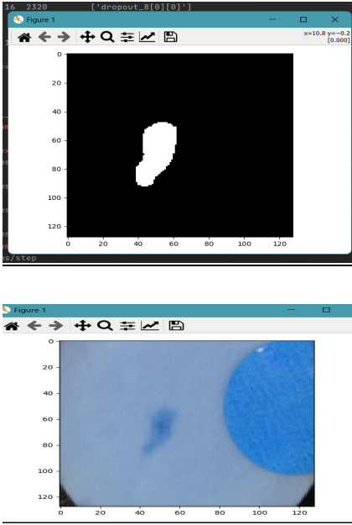

***using ResU-netplusplus***

The training dataset consists of two components: the original Color picture and the image mask. In the image affected areas and their mask images are shown below. Dataset has total 1259images for train and test in different folder. For train 900 images and for test 359 images along with mask. We made combine them in one file, then 70% images dedicated for train and 15+15= 30% for test and validation. Our train size was 897 and test size was 191 and validation size was 191.

**Result images:**

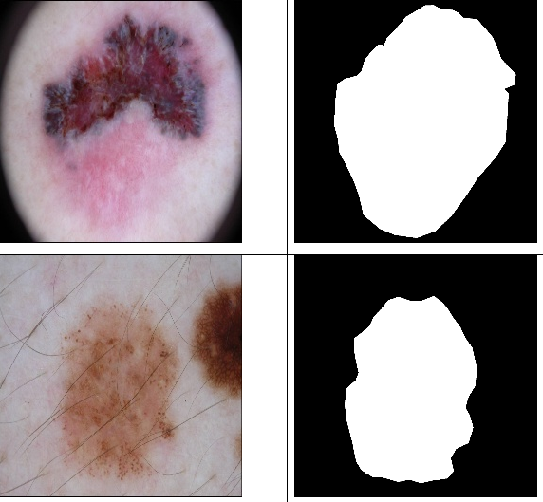

Basic UNet model was implemented to Resunetplusplus model, activation function was sigmoid and it trained used 17 epochs, optimizer “Nadam". Epoch 17, batch size 8, dice coefficient for test data 81.82%. dice coefficient for train data 91.39%.

# **4.2 Impact on Environment:**

Climate change, UVB exposure, and high arsenic levels in drinking water, among other environmental factors, have all been linked to melanoma, SCC, and BCC. As the incidence rate of melanoma and non-melanoma skin cancers rises worldwide, A better knowledge of the underlying causes is a necessary first step in preventing them. Despite a considerable corpus of research on skin carcinogenesis, earlier investigations have failed to identify all of the environmental skin cancer risk factors as a result, more research is needed to study the potential impact of other potential risk factors and to implement prevention strategies based on avoiding them.

# **CONCLUSION**

In this paper, a Convolutional Neural Networks based approach have been proposed for melanoma classification. A system is developed that can help patients and doctors to be able to detect or identify skin cancer classes whether it is benign or malignant. From the experimental and evaluation section, it can be said the model can be considered as a benchmark for skin cancer detection by assisting healthcare professionals. By taking some random images any doctor can identify the accurate results but in traditional approach too much time are taken to detect the cases correctly. Human beings are protected by their skin against environmental pollution, but the adverse effects of ultraviolet radiation increase the risk of melanoma. We propose a deep learning framework to segment, detect, and classify skin lesions in dermoscopic images for melanoma detection. Based on the publicly available dataset ISIC 2016, which consists of seven lesion categories, we evaluated the proposed framework. Our model outperformed the existing models in terms of performance. As a result of the current study, the uncertainties in boundary detection were removed, reducing the loss and the processing time. the results suggest that the proposed model is computationally efficient.

Future research aims to develop hybrid artificial intelligence techniques employing the  
following genetic algorithms; hybrid of fuzzy inference system (FIS), Ant Colony  
Optimization (ACO), called PSO-ACO, Ontology, Contour let Transform and others in  
multifunction pattern recognition systems.

# **REFERENCE**

* Use APA referencing style to provide references to citation you have used in the thesis/project repot text.
* You may find some example here <https://en.wikipedia.org/wiki/APA_style>